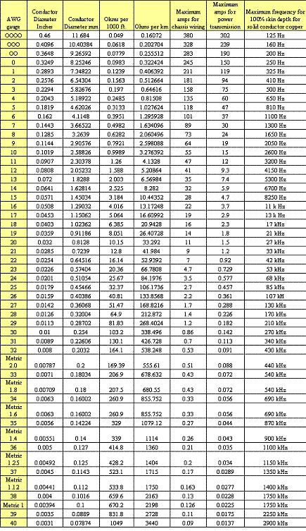

**MM to AWG Conversion Chart, Calculator, and Metric to AWG Table**

|  |  |  |  |
| --- | --- | --- | --- |
| **USA Wire & Cable size** | **EU** **Metric MM2 size** |  | **Max ampere Rating** |
| AWG, MCM, or  kcmil | mm2 |  | Amps |
| 30 | 0.05 |  | 0.5 |
| 28 | 0.08 |  | 0.8 |
| 26 | 0.13 |  | 1 |
| 24 | 0.20 |  | 2 |
| 22 | 0.32 |  | 3 |
| 20 | 0.52 | 0.5 | 5 |
| 18 | 0.82 | 0.75 | 7 |
| 16 | 1.3 | 1.5 | 10 |
| 14 | 2.08 | 2.5 | 15 |
| 12 | 3.31 | 4 | 20 |
| 10 | 5.3 | 6 | 30 |
| 8 | 8.4 | 10 | 50 |
| 6 | 13.3 | 16 | 65 |
| 4 | 21.2 | 25 | 85 |
| 3 | 26.6 |  | 100 |
| 2 | 33.6 |  | 115 |
| 1 | 42.4 | 35 | 130 |
| 1/0 | 53.5 | 50 | 150 |
| 2/0 | 67.4 | 70 | 175 |
| 3/0 | 85.0 | 95 | 200 |
| 4/0 | 107 | 120 | 230 |
| 250 | 127 |  | 255 |
| 300 | 152 | 150 | 285 |
| 350 | 177 | 185 | 310 |
| 400 | 203 | 185 | 335 |
| 500 | 253 | 240 | 380 |
| 600 | 304 | 300 | 420 |
| 700 | 355 |  | 460 |
| 750 | 380 | 400 | 475 |
| 800 | 405 | 400 | 490 |
| 900 | 456 |  | 520 |
| 1000 | 507 | 500 | 545 |
| 1250 | 633 |  | 590 |
| 1500 | 760 |  | 625 |
| 1750 | 887 |  | 650 |
| 2000 | 1010 |  | 665 |

**Amperage (Amps) versus Wire & Cable Size [ MM to AWG ]**